Registered Charity in N.I.(NIC105562)

Website: www.portstewartpresbyterian.org

#### Welcome

**Good morning and welcome to Portstewart Presbyterian Church.**

This announcement sheet is designed to keep you up to date with church life. Our Minister is **Stuart Morrow,** and he is available if you need to speak with him after the service or at another time.

**Stuart Morrow**

**02870836232**

**07515553939**

**Stu**

**art Morrow**

**0751555393**

**PRAYERTIME** before worship in the **Centenary Room** 9.45 – 10.10 am

**CRECHE** is in the Creche Room **from 10.15 am**

**What’s happening**

**15th to the 21st June 2025**

**10.30 am Robert Walker will talk**

**about Open Doors**

**Sunday Prayer and Praise Service** at6.30 pm in

the Centenary Room

**Tuesday Kirk Session Meeting** at 7.30 pm in the

Minor Hall

**Wednesday Church Art Group** 10.30 – 12.30 pm in

the Main Hall

**Thursday CAMEO** will meet2.30 – 4.00 pm in the

Centenary Room

**What’s happening**

**in July 2025**

**KESWICK AT PORTSTEWART**

**Saturday 5th July to Friday 11th July**

**(Please see back page for further details)**

**CSSM**

**Sunday 6th July to Friday 18th July**

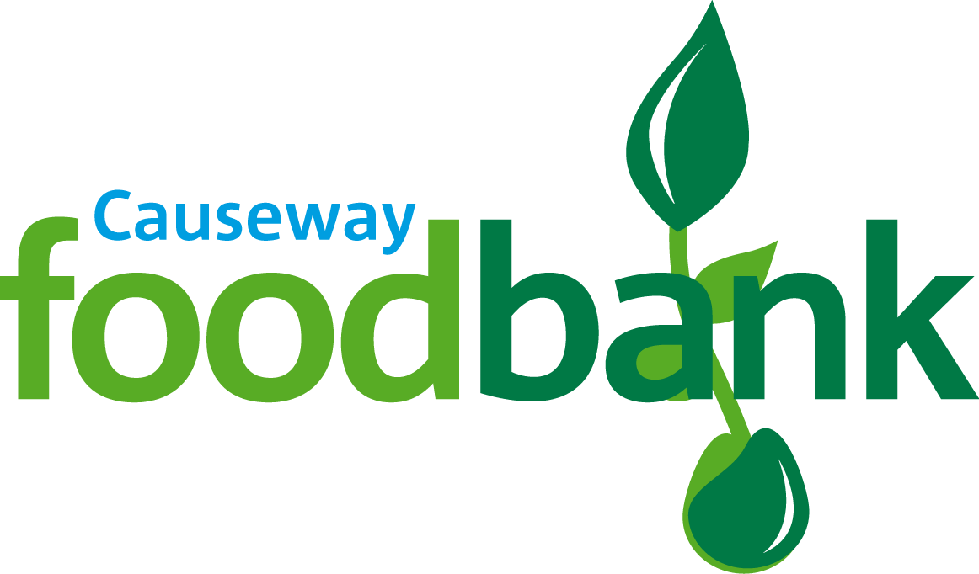

**Please remember the food bank in the vestibule.**

**Welcome Rota**

June **Derrick Turbitt,** Helen Davies, Dorothy Friar, Sarah Powers,

Hazel Walker, Jimmy Wright

**Creche Rota**

15th June Stanley and Valerie Stewart

22nd June Rebecca McCormick and Gillian Lemon

29th June Barbara Hall and Karen Scott

**Flowers** The church flowers today were kindly donated by Julia Ross

in memory of her mother Doreen

**Treasure Hunters** Wendy Porter and team

***Tea and coffee will be served in the Link after the morning service***

# Other Notices

**PASTORAL CARE** If you know of anyone who is ill or in hospital please contact Stuart with their name and details.

**HELP NEEDED:**  An  urgent appeal for any spare toiletries: shampoo, deodoramt, soaps, conditioner body lotion plus baby clothes and small toys to help some local traumatised families. Also women's personal Self-Care products.   Donations can be left at Star of the Sea Parish Centre behind Buds on **Tuesday 17th June** between 1300 and 1700. All much appreciated.  Call 07826315543

# Points for Prayer

**Sunday 15th June**

Read Isaiah 9:6. **For a child will be born to us, a son will be given to us, and the government will be on his shoulders. He will be named Wonderful Counsellor, Mighty God, Eternal Father, Prince of Peace.**  It has been a week of violence, anger, hatred and in some instances racism. What is our response, certainly to clearly state that what has been happening has been wrong. More importantly our response should be to pray that the **Prince of Peace**, the **Wonderful Counsellor** would bring his peace into what is happening.

**Monday 16th June**

Read Psalm 86:9. **All the nations you have made will come and bow down before you, Lord, and will honour your name.** Israel and Iran are fighting, war in Ukraine, Gaza, Sudan, Myanmar, Ethiopia, Yemen and the Democratic Republic of Congo to name only some of the conflicts. Pray that the day will soon come when all the nations bow before God bringing honour to his name.

**Tuesday 17th June**

Read Matthew 24:6-8. **See that you are not alarmed, because these things must take place, but the end is not yet.** Take time to remember that it is God who holds time and history in his hands. Praise God that one day he will bring all war to an end with the return of Christ but also pray that we would have the courage to proclaim that day so that as many as possible will be ready for his return.

**Wednesday 18th June**

Read Esther 4:14. **Who knows, perhaps you have come to your royal position for such a time as this.** Pray for all who have positions of influence over the violence we see in our world. Pray for local politicians here who can diffuse the tensions and change the culture of suspicion and unwelcome that is harming our communities and indeed our world.

**Thursday 19th June**

Read Revelation 7:9 **After this I looked, and there was a vast multitude from every nation, tribe, people, and language, which no one could number, standing before the throne and before the lamb. They were clothed in white robes with Palm branches in their hands.** Take time to think about how we have all been created in the image of God, how we are redeemed by the Son of God and one day we will also stand before the throne of God. Thank God that we are all one, regardless of language or race, in Jesus Christ.

**Friday 20th June**

Read Colossians 4:5. **Act wisely towards outsiders, making the most of the time. Let your speech always be gracious, seasoned with salt, so that you may know how you should answer each person.** As we respond and comment on the local and worldwide events of last week ask God for wisdom in what we say and how we act towards others. Remember that we are called to season all our words and actions with the salt of the gospel.

**Saturday 21st June**

Read 1 John 4: 19. **We love because he first loved us.** Think of the way in which God has loved us. Jesus died for us despite our rejection of him. Pray that we would love in the way we have been loved.

