

Registered Charity in N.I.(NIC105562)
Website: www.portstewartpresbyterian.org

PRAYERTIME before worship in the Centenary Room 9.45 – 10.10 am

CRECHE is in the Creche Room from 10.15 am

Welcome

Good morning and welcome to Portstewart Presbyterian Church.
This announcement sheet is designed to keep you up to date with church life. Our Minister is Stuart Morrow, and he is available if you need to speak with him after the service or at another time.
Stuart Morrow
02870836232
07515553939

Stu

art Morrow
0751555393

What’s happening
10th to 16th September 2023

Sunday Youth Fellowship 6.30 pm Church Hall

Monday Bowling Club 7.00 pm Church Hall

Wednesday Little Treasures (Parent & Toddlers)
10.00 am – 12.00 noon in the Minor Hall

Church Art Group 10.30 – 12.30 pm in the
Main Hall

Girls’ Brigade Explorers 6.00 – 7.15 pm
Company Section 7.15 – 8.45 pm
Events Committee Meeting 7.15 pm in
the Centenary Room

Thursday Coffee Time 1.45 pm – 4.00 pm in the
Minor Hall. Come along for a cuppa and
chat between the school pick up times.

Bowling Club 7.00 pm Church Hall

Bible Study Group at 7.30 pm in the
Minor Hall.

Saturday Blaze 6.00 pm and CHILL 7.30 pm


Please remember the food bank in the vestibule.

Welcome Rota
September Arnold Brown, Rosie King, Samantha McPeak, Neil Pierce,
Julia Ross, Julie Watters

Creche Rota
10th September Barbara Hall and Julia Morrow
17th September Maude Lyttle and Julie Watters

Flowers The church flowers today were kindly donated by Jennifer Wilson

Treasure Hunters
September Julie Watters and team

Tea and coffee will be served in the Link after the morning service

Other Notices

PRAYER AND PRAISE will begin in the Church on Sunday 17th September at
6.30 pm. This will take place on the 1st and 3rd Sundays of the month.
STATED MEETING OF CHURCH COMMITTEE on Tuesday 19th September at
7.30 pm in the Minor Hall.
CAMEO are returning to the Centenary Room for their winter meetings. Please see poster overleaf for full details. The next meeting is Thursday 21st September.
FLOWER ROTA The Flower Rota for 2024 is being prepared. If anyone would like to provide flowers in 2024 or become involved in the arranging of flowers please contact the Church Office at 70834529 or speak to Helyn Kirkpatrick.
PORTSTEWART CHURCHES FRIENDSHIP GROUP invite you to a ‘Quiet Day’ in Corrymeela, Ballycastle on Tuesday 17th October 9.30 am with tea/coffee before. Cost, £25 includes lunch. Please book your place by signing the sheet in either the Vestibule or Link. Last date to register is Thursday 28th September.

ELECTION OF ELDERS
We plan to have an election of up to 4 elders with voting beginning on Sunday 1st October. We would encourage you to prayerfully consider who God is calling to this position.
A list of full voting members will be on display in the Link and Vestibule today and next Sunday, 17th September. If you are a full member, you are eligible to vote. Please ensure that your name is on the list. Any objections should be made in writing by 6.00 pm on Sunday 17th September.
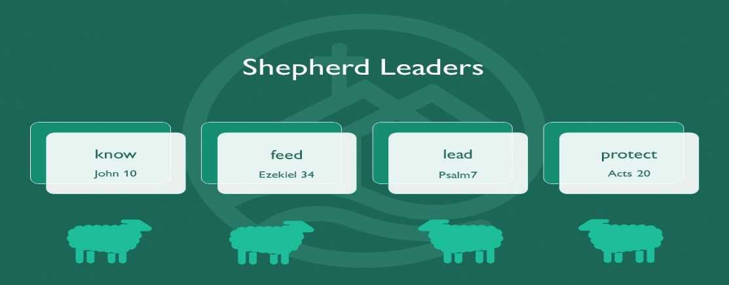

Let’s Pray Sun 10 to Sat 16 September 2023
Sunday 10 September
• Moderator | The Moderator, Rt Rev Dr Samuel Mawhinney, will be preaching in 1st Bangor and Strean Presbyterian Churches in Ards Presbytery. Pray for Rev Mairisine Stanfield and her husband David as 1st Bangor thanks God for 400 years of Presbyterian witness in Bangor. Remember ministers and their families who are approaching retirement and attending a residential event (Wednesday 14) to aid their preparation.
• Knowing the blessings of God in worship | ‘May the God of hope fill you with all joy and peace as you trust in him, so that you may overflow with hope by the power of the Holy Spirit.’ Romans 15:13. Ask that as you worship today you may know the blessings of God’s overflowing hope, joy and peace.
Monday 11 September
• Edwin and Anne Kibathi (global mission workers, England) | Pray that our trip to Glasgow will be safe & that it will be a time of refreshment & renewal. Pray for the mission month in the wider PCEA (Presbyterian Church of East Africa) & that the scheduled events and services will make an impact both within and outside our congregations to the glory of God.
• Presbyterian Church of Myanmar (PCM) | Pray for members of Presbyterian congregations who have had to flee their villages due to attacks by the Myanmar military, especially those who have been detained, beaten and the grieving families of those who have been killed.
Tuesday 12 September
• John Coulter, chaplain, Ulster University, Coleraine | Pray that John would make good contacts with students & staff at the start of a new academic year & that helpful gospel relationships will be developed. Pray that members of the CU would get involved in the Ballysally Homework Club & would be encouraged in their faith as they serve in this practical way.
• Dundalk | Give thanks for the holiday Bible club that took place over the summer. Pray for the congregation’s new young adults’ group that will meet every other Sunday evening. Pray for the Sunday services, that God's Word would dwell richly in the hearts of all who hear it.
Wednesday 13 September• Csaba and Ilona Veres (global mission workers, Romania) | Pray for the Diakonia staff in Salaj County as they bring the love of Jesus to families and teach, support and nurture children. Pray God will equip, inspire, and strengthen them at the start of the school year.
• Theological Education by Extension, Malawi (TEEM) | Pray for Rev Chimwemwe Mitengo, Director, that he would know God's wisdom, guidance and encouragement in taking forward the work of TEEM.
Thursday 14 September
• Welcoming the Stranger | Pray for this event happening on Saturday, for congregations in PCI that are responding in creative and meaningful ways to welcome newcomers. Pray that those who attend will feel encouraged and equipped to welcome and share the gospel with people making Ireland their new home.
• Mission in Ireland personnel | As a new term begins pray for all involved in missional activities within PCI congregations. That programmes would be strategic and effective in reaching those in communities around Ireland for the gospel.
Friday 15 September
Tritonville Close | This service is located in Sandymount village, Dublin, and offers care and support for older people. Pray for Richard Zipser, the manager, and the management committee as they seek to oversee the service in the best interest of the residents to support them.
• Further & Higher Education | Pray for young people moving into higher or further education and especially for those who might be leaving home for the first time. Give thanks for Christian Unions and local churches who are preparing to welcome students and pray that they would have many opportunities to share the love of Jesus.
Saturday 16 September
• General Council | Pray for the meeting of the General Assembly Arrangements Panel taking place next week as the convener, Rev Mervyn Burnside, leads the group in a review of the practical logistics for the 2024 Assembly.
• Training in Ministry | An induction day for ministry students is planned for 22 September. This gives time for worship, prayer and fellowship, along with preparation for the new academic year. Pray for the ten new students starting their training & for the second- and third- year students who are returning to full-time study after their summer placements.



Please note: As our Church Services are recorded and available to watch on the church website anyone not wishing to be on camera should sit in the balcony.

